Latin Alive! Unit 1 Readings Name _______________________
Monday Date ______________Period ____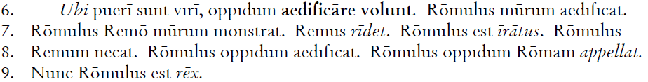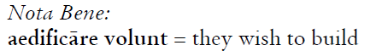
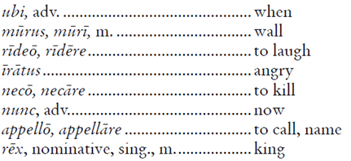
Questions
- In (6), what does Romulus build?

- In (7), to whom is the wall shown?

- In (7), describe Romulus.

- In (8), what is the direct object of ‘aedificat’?

- In (9), what is Romulus?

Latin Alive! Unit 1 Readings Name _______________________
Monday Date ______________Period ____
Questions
- In (6), what does Romulus build?

- In (7), to whom is the wall shown?

- In (7), describe Romulus.

- In (8), what is the direct object of ‘aedificat’?

- In (9), what is Romulus?

